**Executive Summary for Mapster**

**Motivation**  
Mapster is designed to inform travelers about the overall safety of a given country or region. Without having to read website upon website, travelers can get the 'big picture' about the safety of a country just by looking at our intensity maps - either an overall score or scores based on individual safety concerns such as crime or natural disasters. Mapster also allows users to look at real-time and historical travel warnings from the [U.S. Department of State](http://travel.state.gov/travel/cis_pa_tw/tw/tw_1764.html) and [U.K. Foreign & Commonwealth Office](http://www.fco.gov.uk/en/travel-and-living-abroad/travel-advice-by-country/).

**Related work**

**Trulia** – provides a crime rate heat map on specific cities in the United States. Whereas Trulia only considers crime, Mapster allows users to review conditions for six different categories: Natural Disaster, Politics, Epidemics, Crime and Terrorism, Nuclear and Others (includes Pollution). Moreover, Trulia only considers specific cities in the United States whereas Mapster aims to capture the safety level across the globe, which would be helpful for international travelers.

**Approach**

*Inputs:*

* News articles from Bing, The New York Times, and USA Today web APIs
* Tweeter feeds from U.S. Department of State and U.K. Foreign & Commonwealth Office

*Algorithm:*   
The inputs were parsed looking for specific keywords. The scoring criteria were based on keyword and source weighting depending on the severity of the event. Also, term and document frequency (tf-df) was taken into account while computing the “safety” scores. The appearance of the same keyword across many documents indicated that it is popular; therefore, a higher score was obtained.

*Output:*

* Severity score for each category and top links
* Create the heat map based on these results.

Figure 1. Inputs, Safety Score Algorithm, and Outputs

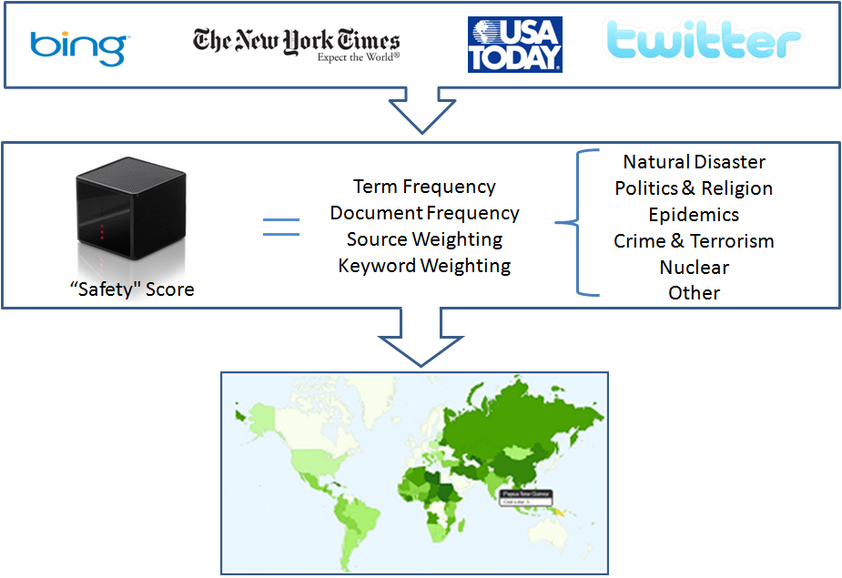

**Technical Depth**

The scoring algorithm obtained news articles about a country from the mentioned APIs and parsed them looking for specific keywords. Our algorithm calculated a score for each news article based on the predefined keyword weightings. Each category contains a set of keywords. According to this set, we classified the news articles into six different categories. We keep track of the top three highest score links. As shown in Figure 2, Italy’s safety score for the crime and terrorism category (0.84) is high in our scale from 0 to 1. Its three links talk about the explosion of a letter bomb at an office of Italy’s tax collection agency.

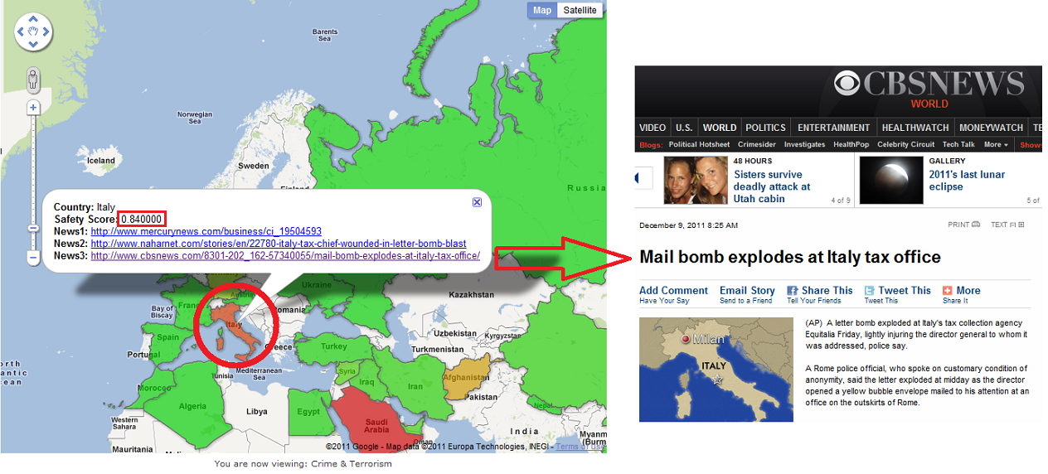

Figure 2. Italy’s severity score on Crime & Terrorism

**Interesting Aspect**

Heat map visualization of the safety score

After the scores have been calculated, they are then updated to a table used to store the scores for each country in each category. We use Google’s Fusion Table because it provides SQL commands that we can call to update the table information and also provide us the ability to display the information through Google Map, using geometry data of the countries. Links are also displayed on the map when a country is clicked to allow users to read the news that contributed to the safety score. Safety scores are calculated and updated on a daily basis.

**Challenges and Future Work**

*Challenges:*

* It was challenging to determine an accurate safety score for every news because a phrase such as “…landslide victory” could be mistaken as a natural disaster.

*Future Work:*

* Improve on safety score accuracy
* Allow the user to query for a country in order to be able to obtain its safety score and links to those articles.
* Compute the safety scores for all the countries in the world.
* Allow the user to query for states and cities.
* Allow user to enter their nationality, and include that in the calculation of the safety scores.